**ASSIGNMENT – 2** PLASMA DONOR APPLICATION

|  |  |
| --- | --- |
| Assignment Date | 27. 09.2022 |
| Student Name | CHANDRU M |
| Student Roll No | 723619104006 |
| Max Mark | 4 Mark |

Question :

1. Create a Flask App
2. Add the Home page, About page
3. Add the Bootstrap
4. Add the Sign in page and App the Signup Page + (add database)

**Home page :**

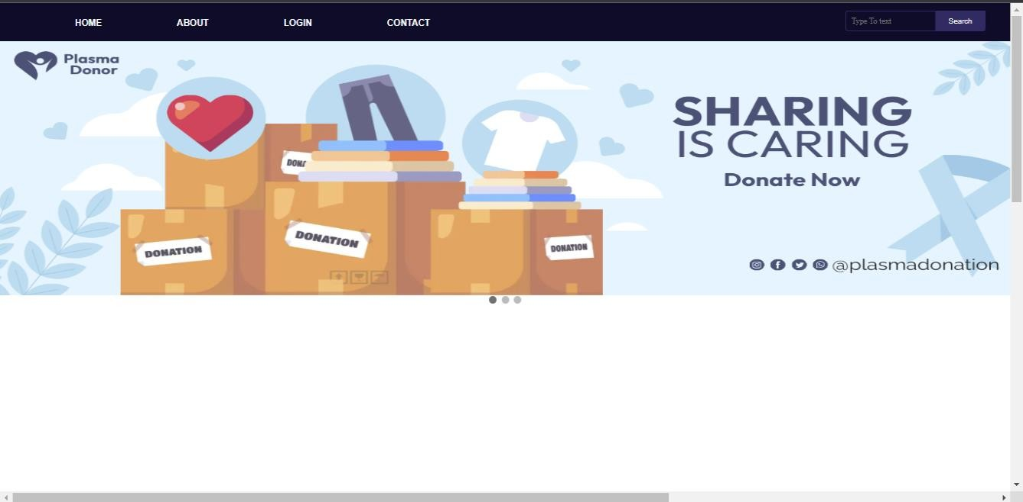

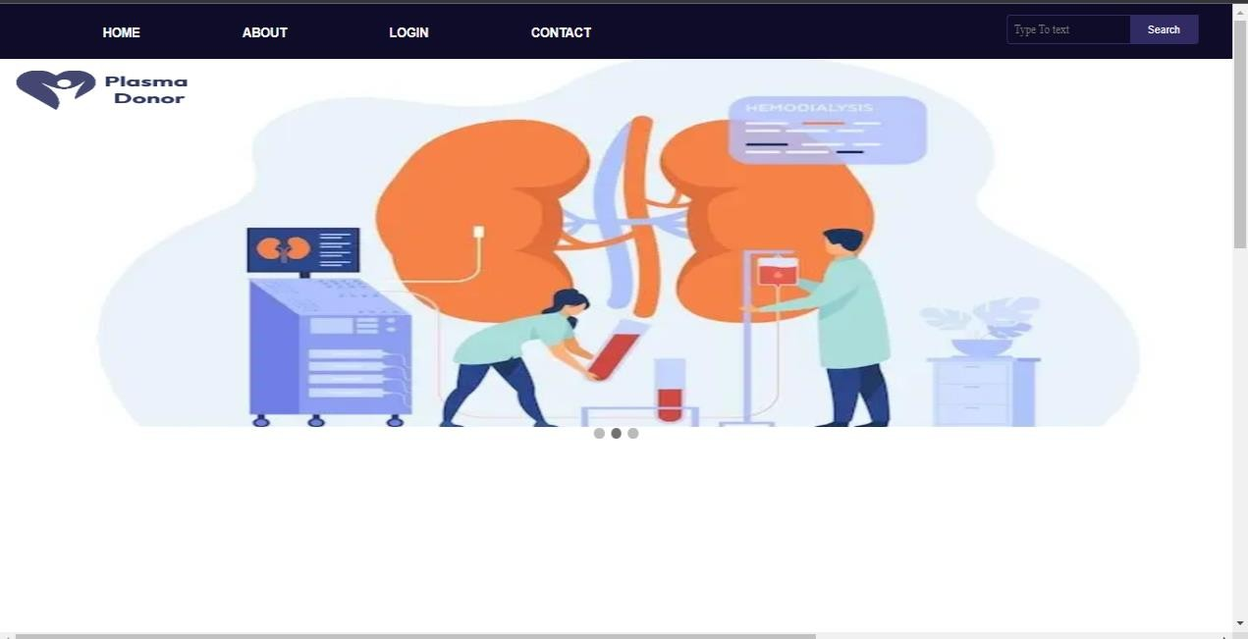

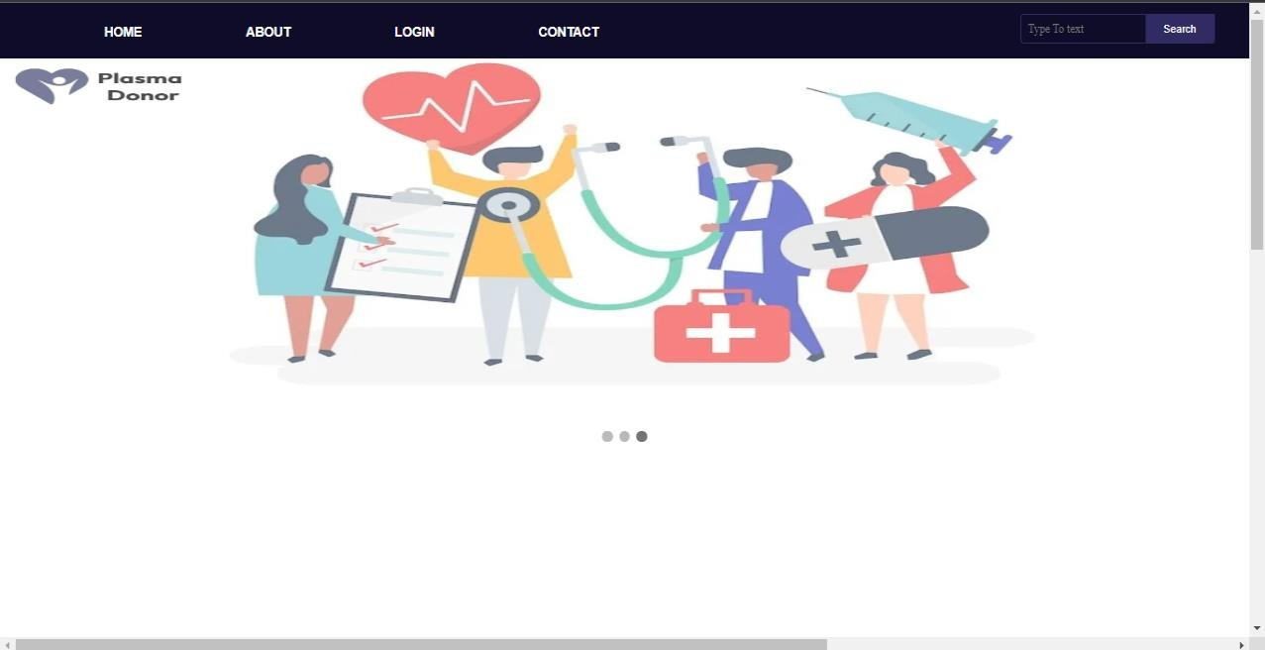

**Sign in Page :**

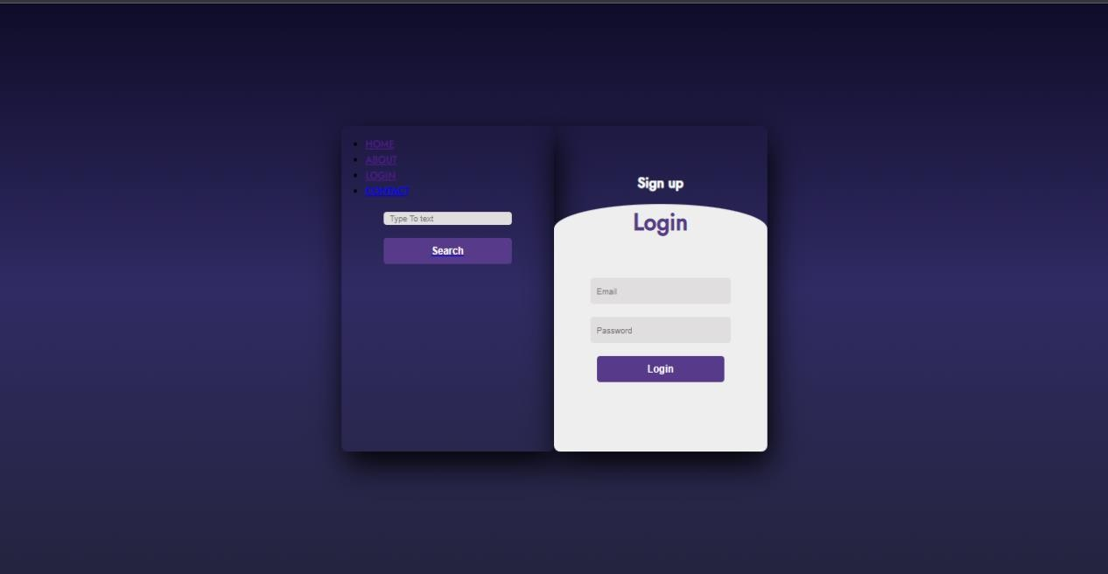

**Sign up Page :**

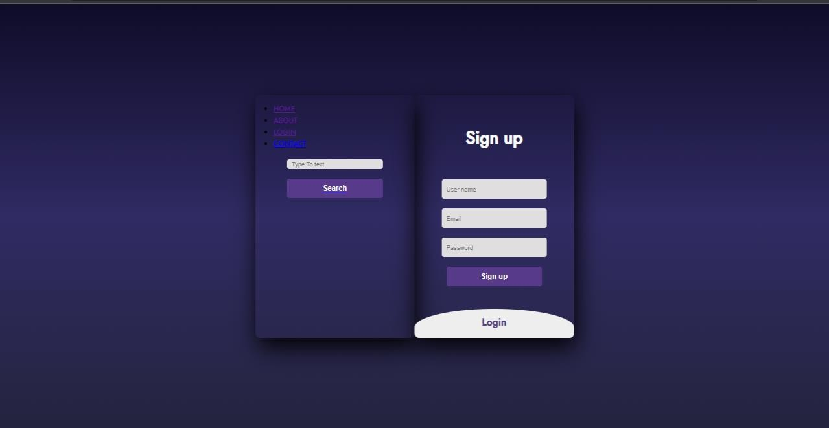

**About page:**

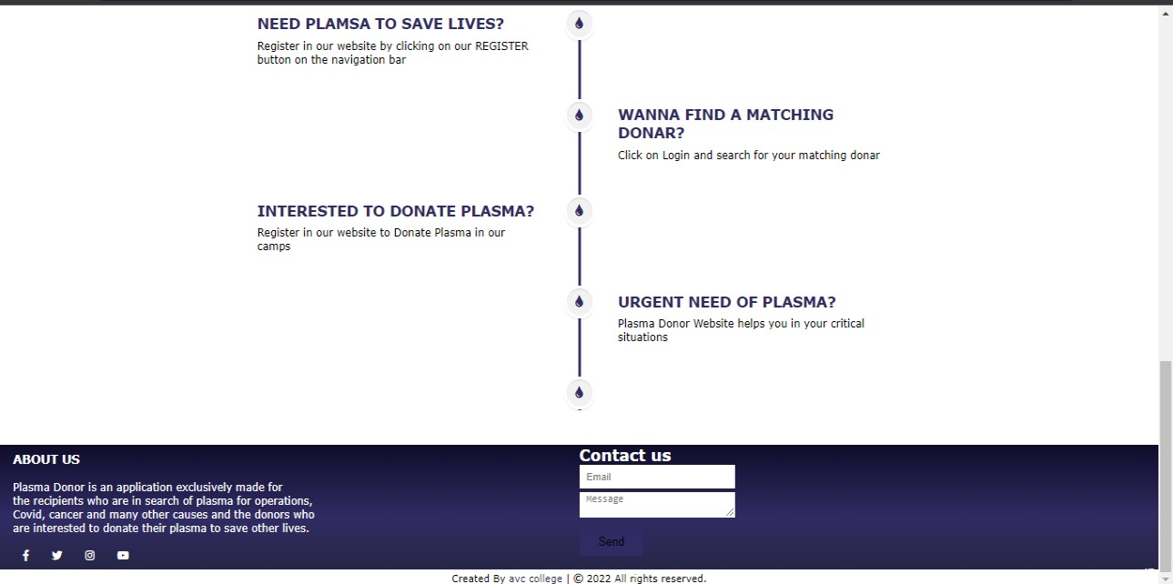

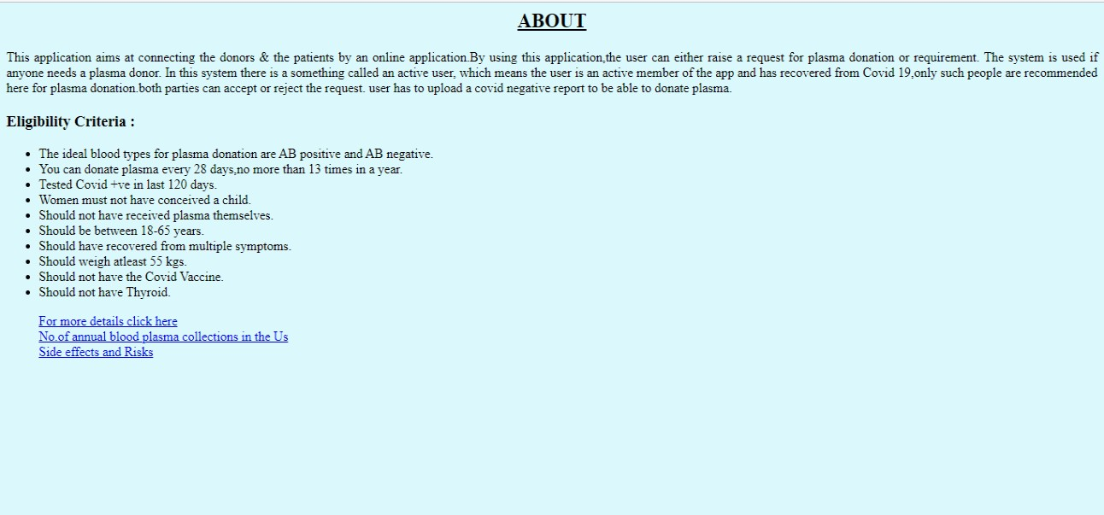

**Contact:**

